Imran Solim

Student ID: 200948533  
Email: ll14i2s@leeds.ac.uk

COMP3811 COMPUTER GRAPHICS

Contents

Introduction 2

Band 1 (40%-50%) 2

Band 2 (50%-60%) 3

Band 3 (60%-70%) 4

Band 4 (70%-100%) 5

# Introduction

An interactive animated scene was created using OpenGL in Qt. The scene consists of a plane flying through a ring in a circular pattern with the camera (or user) in a middle of a path. The path has two small fields to either side with various objects placed on them. The interactions include allowing the user to move around the scene, change field of view angles, change the speed of the plane and disable/enable specular lighting. There are 4 bands we will go through.

# Band 1 (40%-50%)

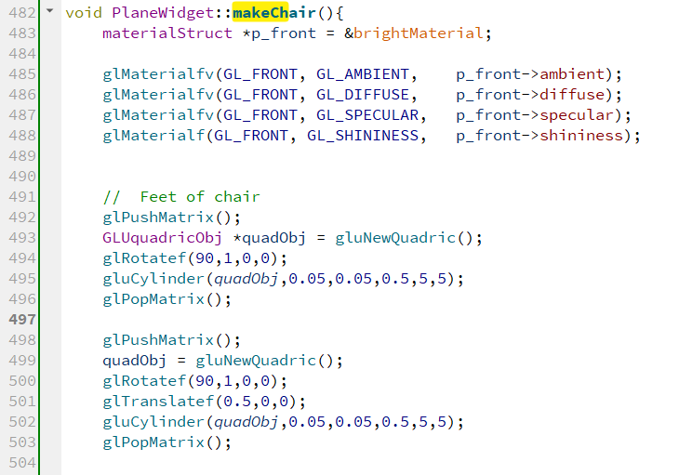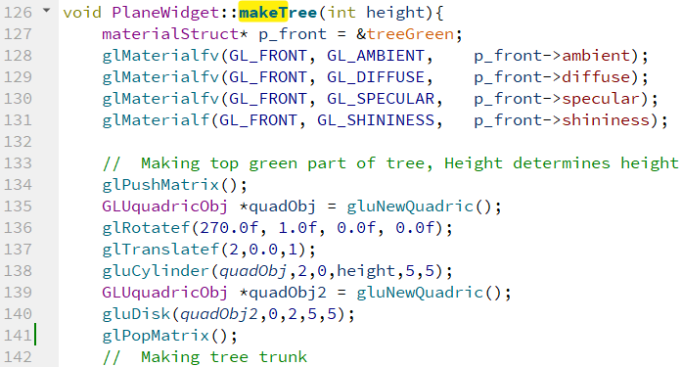When first rendering the scene, the camera is placed slight above a path in the middle. In front of the camera is a red ring where a plane will fly through. On the left-hand side of the path is a field that consists of trees and chairs.

*Figure 1: functions to render a tree and a chair*

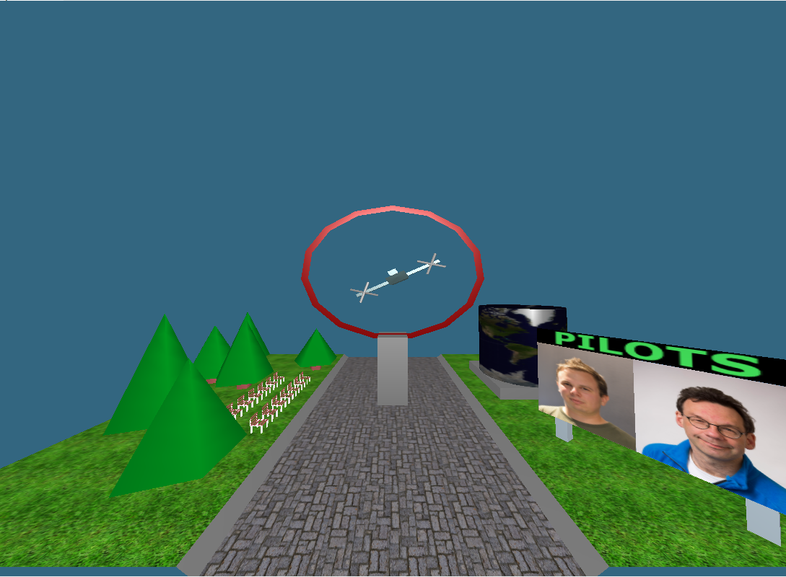The trees were made using the functions ‘gluCylinder()’ and ‘gluDisk()’ and the tree was rendered with a function ‘makeTree(int height)’ where the height determines the height of the tree. There are also chairs in between the trees. The chairs were made using ‘gluCylinder()’ and using ‘glVertex3f()’. The grass is a flat plane that is textured by using ‘glEnable(GL_TEXTURE_2D)’ and ‘glTexCoord2f()’. The path is also textured this way. On the right-hand side is another field that also contains various objects. One object is a stand that contains textures of two people and a texture of a text which is ‘Pilots’. There is also a spinning cylinder that has a texture of the world map. All of these objects were made using the same methods as the previous objects explained above.

*Figure 2: showing the entire scene*

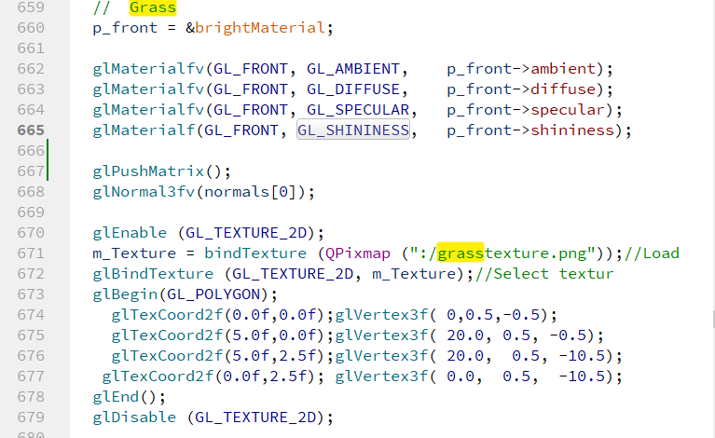

There was a single light source that was white in colour and was placed just above the camera by using ‘GL_POSITION’ with a value of ‘0,5,0’ and using the function ‘glLightfv()’. Ambient, diffuse and specular lighting were used with a strength of 0.5, 0.8 and 1 respectively. Material properties were also modified by using a structure called ‘materialStruct’ which modified material colours and light properties. Specular lighting can be seen clearly on the ring stand and the cylinder and diffusive light more clearly on various cubic objects.

*Figure 3: Code showing applying grass texture on a polygon*

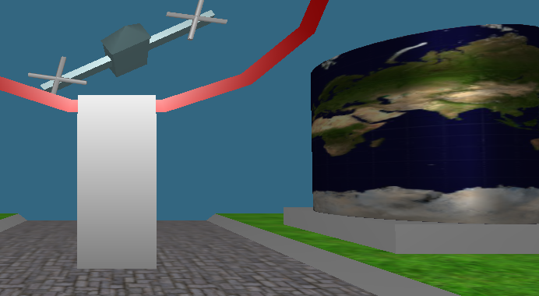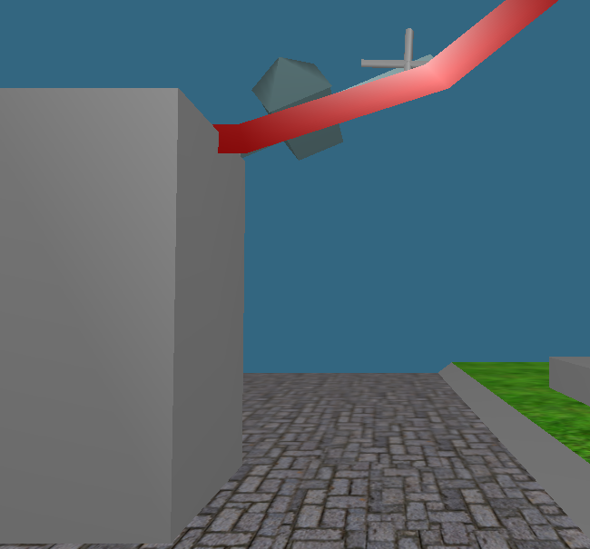

*Figure 4: Demonstrating specular lighting*

*Figure 5: Demonstrating diffusive lighting*

# Band 2 (50%-60%)

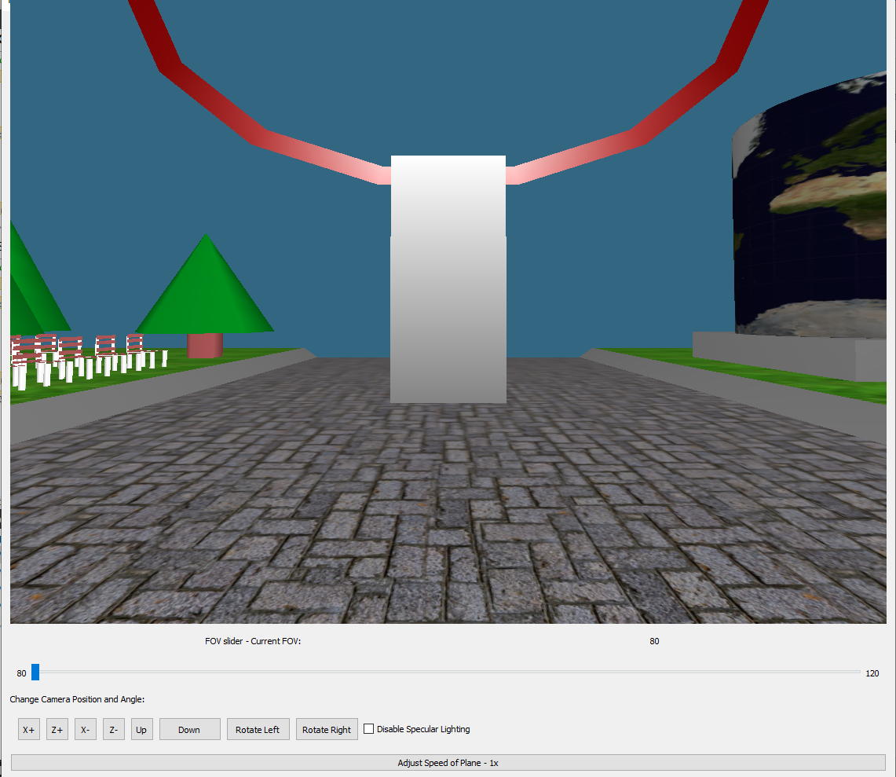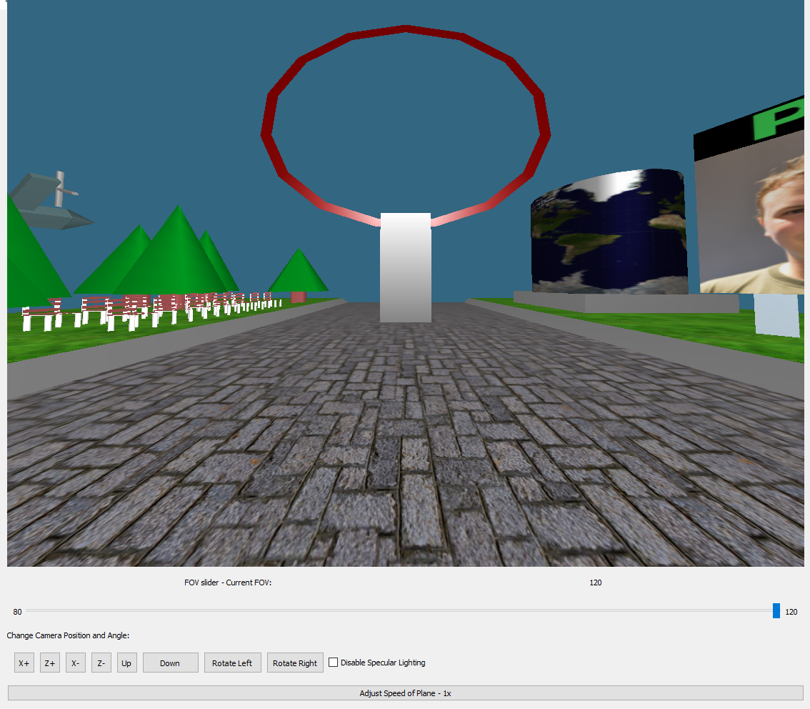There are several user interactive elements. A field of view slider exists as well as a check box that disables/enables specular lighting.

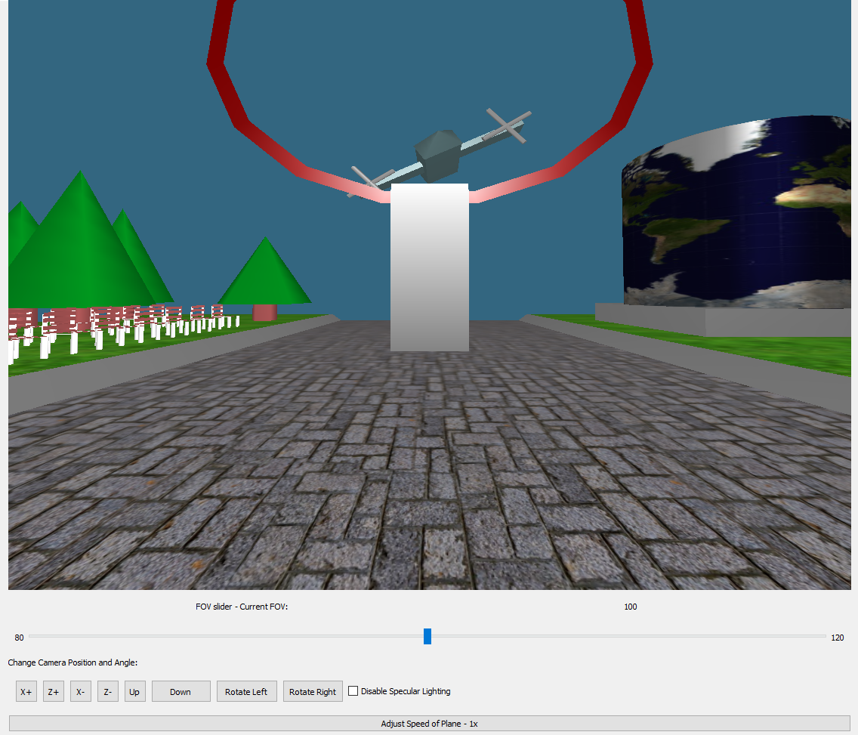

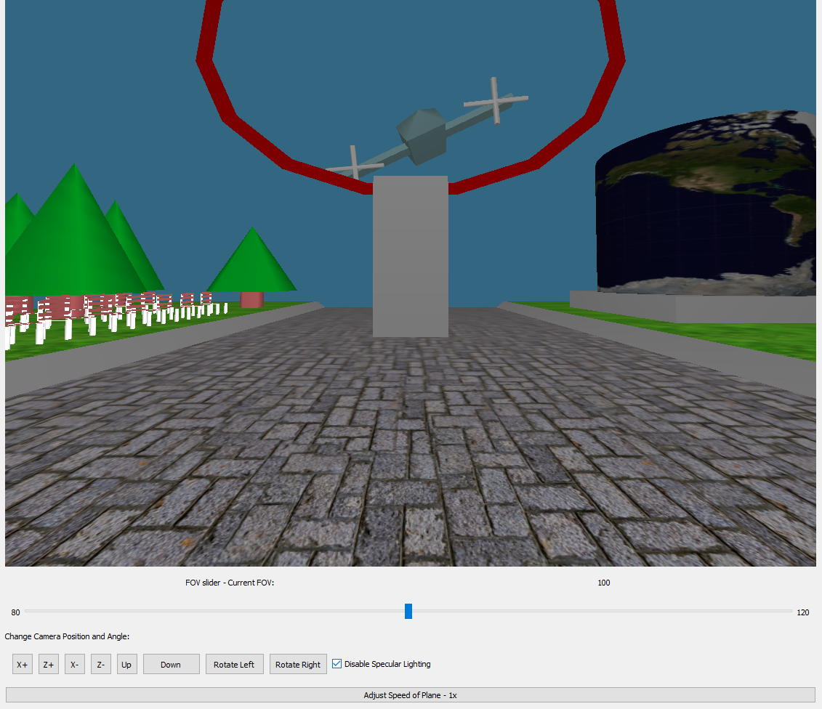

*Figure 6: field of view (FOV) change from 80 degrees to 120 degrees by dragging the FOV slider*

*Figure 7: disabling specular lighting*

# Band 3 (60%-70%)

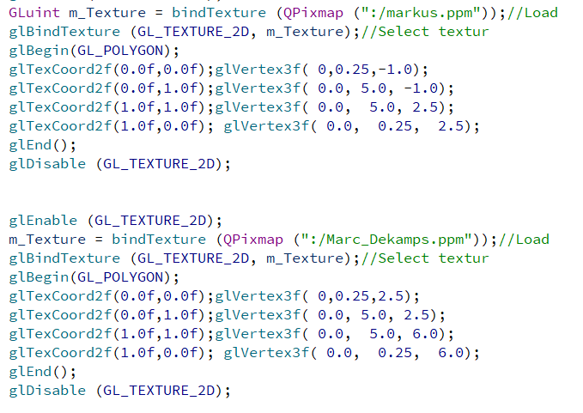There are several elements of animation. For example, the plane and its fans and also the cylinder with the world map which spins. There are also many convex objects such as the ring stand made up of a cube with 6, 4-sided polygons. The cubes were made in a function called makeCube(). The plane was also mostly made up of cubes and each cube was scaled accordingly. There are many textures, the stand has pictures of two people and the cylinder contains a texture of the world map.

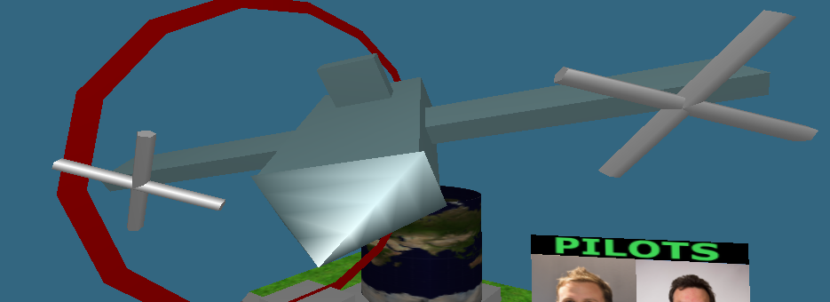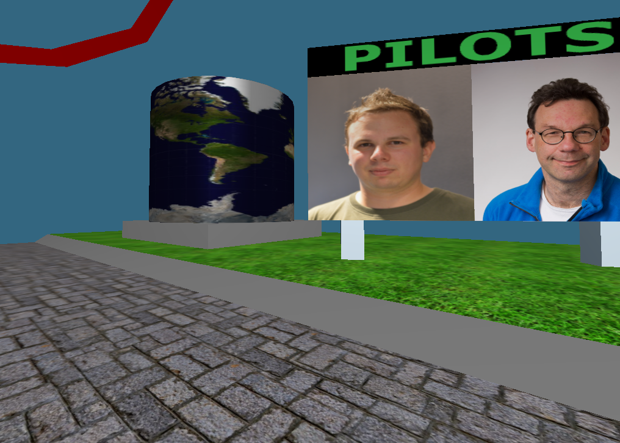

*Figure 8: showing textures of posters of people and corresponding code*

*Figure 9: Plane made up of cubes and cylinders*

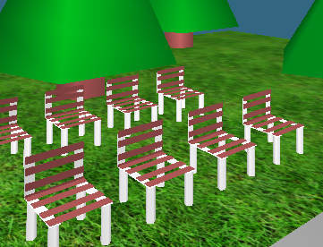

*Figure 10: chairs made up of cylinders and flat polygons*

# Band 4 (70%-100%)

There are several objects made using hierarchical modelling such as the plane or the world map cylinder with stand. The cylinder also spins. The fans of the plane also spin, and the plane moves in a circular motion through the scene. There are various user interactive controls such as disabling or enabling specular lighting as shown above, increasing the speed of the plane that also increases its fan speed. There are also several buttons to allow the user to move in the x,y or z direction as well as rotating left or right.

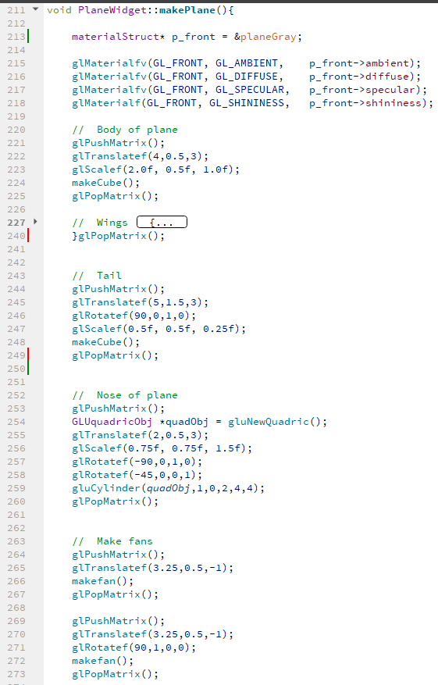This is the hierarchical model for the plane. It is made up of several different cubes using the function ‘makeCube()’ and it was scaled and translated as needed. It was also made up of a cylinder using ‘gluCylinder()’ and fans from the function ‘makefan()’.

*Figure 11: code showing hierarchical modelling of plane*

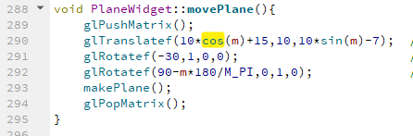

This function positions the plane and moves it in a circular path with a radius of 10as seen in line 290 and then the plane is rendered using the function ‘makePlane()’.

*Figure 12: code showing position and circular path of plane*

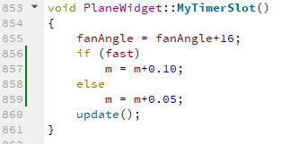This function adjusts the speed of the plane by 1 times or twice the speed. It also updates the fan angle and spins it by 16 degrees every 50 milliseconds.

*Figure 13: code showing adjusting plane speed*

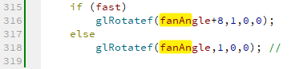This code is in the makefan() function and it toggles the speed of the fan rotation. It increases by 50% if the faster speed is chosen.

*Figure 14: code showing adjusting fan speed*

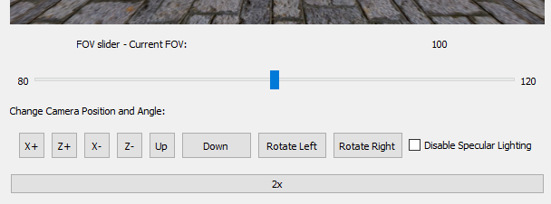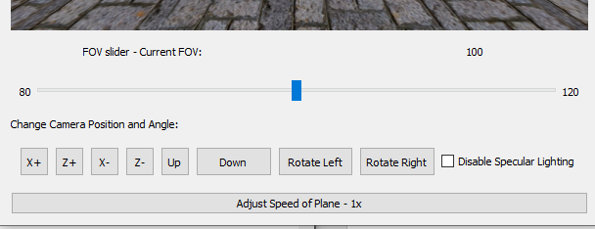

*Figure 16: User interactive elements including adjustment of plane speed after pressing the button*

*Figure 15: User interactive elements including adjustment of plane speed*